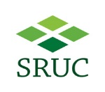
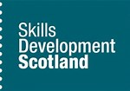
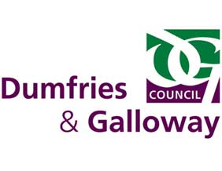
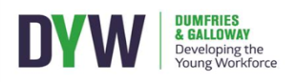
:

Agriculture Apprenticeship Opportunities in Dumfries and Galloway
New Positions for Apprenticeships in Dairy Farming

Up to twelve positions across Dumfries and Galloway are available to gain a fully funded, industry recognised qualification in Agriculture whilst earning and working on a local Dairy Farm.
Qualification: Apprentices will work toward a specialised Dairy MA in Agriculture (Level 2 and 3 qualification). All training & assessment will be provided by SRUC Barony, locally delivered where possible. Support and guidance will be given by experienced dairy farmers.
Based: selected farms throughout Dumfries and Galloway.
Salary Range - Apprentices will be paid at least the minimum salary as agreed by the wages board, rising after 12 months / on completion of the first level in the qualification. There is no cost for the training or entry to the qualification.

Progression: Upon 2 years successful completion of the apprenticeship, candidates will have the skills and opportunity to apply for a range of roles in Dairy Farming or other branches of agriculture – e.g. beef / sheep. Equally the qualification could be used for entry to continue studying in agriculture or a related discipline through college/university or work based learning. Check out www.thisisdairyfarming.com for more info.
How can I find our more? An induction programme will run during June and July to give young people the opportunity to undertake work experience on farm, learn about health and safety and the responsibilities of employees on a dairy farm and take part in an interview process to be selected for the positions.
Hours - Full Time
Duration – 2 Years from August 2018

For more info contact:

george.jamieson@nfus.org.uk

To register interest use the details overleaf and email:

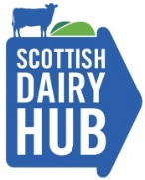
Tracey.mcewan@dumgal.gov.uk
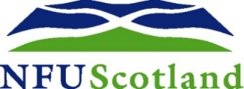

SPECIALIST MODERN APPRENTICESHIP IN DAIRY PILOT – REGSITER INTEREST
- Name
- Current / last school
- Home postcode
- Date of Birth
- Briefly explain why you are interested.
- Detail any relevant work experience
- Have you applied for any other courses / jobs / school subjects?
- Are you able to take part in the induction programme from June – August?

Submitting this does not commit you to starting an Apprenticeship in August but allows you to register interest and take part in the induction programme. In July, those people who have demonstrated the correct attitude and skills will be offered an interview and matched with a suitable farmer to provide employment.

Please return to tracey.mcewan@dumgal.gov.uk by the 15th June 2018 to register interest.

