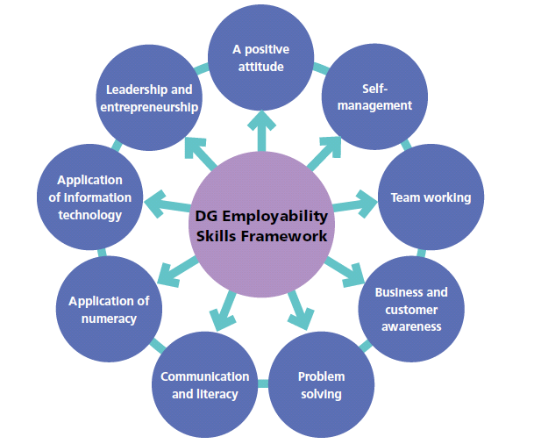
DG Employability Skills Framework
Skills adapted to exemplify pupil language and simplified

What employers want | What does this mean for me now?  Need to provide illustration of what the success criteria would be for this skills in language that young people would understand at the stage they are working at
Business Awareness

Knowledge of roles and business objectives  Business Awareness | BGE: Understanding that a business needs to have customers all year round to sustain it and keep staff on  EARLY: Understanding that to make money a business has to sell all its products for more than it costs to make them  SENIOR: Understand how to market business to increase profit
Sensitive use of data / information

Quality customer service

Working with others internal and external

Dresses appropriately to role

Takes responsibility for achieving results

Willing to develop ideas

What employers want | What does this mean for me now?  Need to provide illustration of what the success criteria would be for this skills in language that young people would understand at the stage they are working at
Enterprise

Creative and original thinking

Ability to lead

Enterprise
Motivates others

Being adaptable

Evaluates risk (and makes good decisions)

What employers want | What does this mean for me now?  Need to provide illustration of what the success criteria would be for this skills in language that young people would understand at the stage they are working at
Digital Skills

Can use common applications | EARLY: can use word / power point etc  BGE: Confident with excel and word  SENIOR: Confident with Microsoft applications
Appropriate use of social media

Research skills
Digital Skills

Presentation skills

Security awareness

What employers want | What does this mean for me now?  Need to provide illustration of what the success criteria would be for this skills in language that young people would understand at the stage they are working at
Communication

Speaks clearly

Appropriate use of language
Communication

Accurate written communication

Good listener

Reads for understanding

Appropriate body language and use of humour

What employers want | What does this mean for me now?  Need to provide illustration of what the success criteria would be for this skills in language that young people would understand at the stage they are working at
Creative Problem Solving

Learns from experience

Evidence based decisions

Flexible approach

Creative Problem Solving
Creative thinking

Selects appropriate resources

Action planning

What employers want | What does this mean for me now?  Need to provide illustration of what the success criteria would be for this skills in language that young people would understand at the stage they are working at
Self-Management

Good timekeeping  Self-Management | EARLY: Turn up on time  BGE: Understand the balance of time over a week  SENIOR: Understanding the importance of working time agreements
Accepts feedback to improve

Uses initiative

Effective time management

Gets involved

Responsibility for health and safety

Positive attitude to work

What employers want | What does this mean for me now?  Need to provide illustration of what the success criteria would be for this skills in language that young people would understand at the stage they are working at
People Skills

Work with others
People Skills

Respects others

Modifies behaviour to support team

Works cooperatively

Challenges appropriately

Contributes confidently

What employers want | What does this mean for me now?  Need to provide illustration of what the success criteria would be for this skills in language that young people would understand at the stage they are working at
Numeracy

Checks for accuracy
Numeracy

Can deal with money, time and measurements

Present, interpret and analyse data

Good mental maths skills

