Halving Dumfries and Galloway’s Disability Employment Gap

A strategy to improve transition, support and inclusion in work

EXECUTIVE SUMMARY
February 2024

In 2016, the Scottish Government set out an ambition to halve Scotland’s Disability Employment Gap (DEG), the difference between the proportion of disabled people employed and non-disabled people employment.

With a target to achieve this across Scotland by 2038 and Action Plan to support it, currently Scotland is ahead of target - meeting its milestone for 2023 last year.

In comparison, Dumfries and Galloway’s DEG has increased by 4% since 2016 and, at 40.4%, makes it the lowest performing local authority in Scotland.

This can be attributed to a combination of economic factors, exacerbated by local factors that include limited transitions support for disabled school leavers; a lack of specialist employability provision to effectively engage and support disabled people into work, and a lack of support for employers to access workplace equality skills and disabled candidates.

In order for Dumfries and Galloway to halve its 2022 DEG by 2038, it requires a long-term strategy to support 5037 disabled people into employment in the region - an average of 336 people annually.

As this is a significant figure, it is not practical for employment support provision to deliver that alone.

As such, a series of recommendations are made to
- Improve transitions support for disabled school leavers
- Establish specialist employment support across the region
- Continue work to improve coordination and management of the existing employability provision
- Foster greater alignment and inclusivity across local businesses
- Enable Dumfries and Galloway’s public sector employers to lead by example

Strategic Policy Context

Scotland’s Disability Employment Gap

In December 2016 the Scottish Government published A Fairer Scotland for Disabled People – Our Action Plan.

It set out over 90 commitments to improve the lives of disabled people, and people with long term health conditions. Over 20 of these commitments relate to work and employment - with the most ambitious being to “reduce barriers to employment for disabled people and to seek to reduce at least by half, the employment gap between disabled people and the rest of the working age population.”

This Disability Employment Gap (DEG) is the difference between the employment rates of disabled and non-disabled people. At the time of publication, the employment rate for disabled people in Scotland was 42.8% compared to 80.2% for the non-disabled working age population. This represented a baseline disability employment gap of 37.4 percentage points.

Thus, to at least halve the gap, the Scottish Government set out to reduce it to at least 18.7 percentage points, with an ambition of doing so by 2038. This meant a reduction of the employment gap by one percentage point every year.

In addition, interim milestones were set for the rate of employment for disabled people - these were 50% by 2023 (5 years from the Action Plan publication) and 60% by 2030.

In order to do so, an update to the strategy was published in 2018, setting out three priority areas for the Scottish Government and specific national actions which were co-produced with disabled people and disabled people’s organisations.

These were:
- Supporting Employers to Recruit and Retain Disabled People - with actions to improve public sector recruitment, the development of a PSP to support employers and a range of health-related work pilots.

- Supporting Disabled People to Enter Employment - with actions to ensure specialist support within the newly devolved Fair Start Scotland, invest in support for parental employability and improve connectivity with Access to Work and Social Security Scotland.

- Young People and Transitions - with actions to apply the Principles of Good Transition across education, improve access to the Developing the Young Workforce programme, Careers service and Modern Apprenticeships and develop more inclusive employability models for disabled young people.

To date, these actions are considered to have made a successful impact at a national level.

In 2022, an estimated 436,400 disabled people aged 16 to 64 were in employment across Scotland - 50.7% of the population - passing 50% for the first time and meeting the 2023 milestone ahead of target.

In the 5 years since 2016, the disability employment rate gap had decreased by 5.5 percentage points from 37.4% to 31.9%.

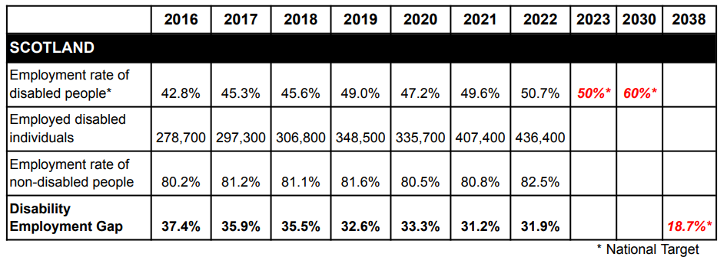

Last year, the commitments of a 'Fairer Scotland for Disabled People' were incorporated into the refreshed Fair Work Action Plan were central to the Scottish Government's 2022 National Strategy for Economic Transformation.

With respect to the DEG, the Action Plan calls for:
- Greater leadership in public sector workforce diversity
- Improved communication of Fair Work practices amongst business
- Continued focus on inclusion of disabled people as part of Fair Start Scotland's replacement
- Continued implementation of the Principles of Good Transition as part of SDS's Careers service.

Whilst resources allocated centrally to local authorities will be used in line with local priorities, it is expected they will continue to contribute to this national ambition for 2038, with their success being monitored centrally against the Shared Measurement Framework - a central methodology of reporting key labour market data across local authorities centrally in a way that reflects individual experiences, impact and public value.

Fairer Scotland for Disabled People
Labour Market Statistical Release
Fair Work Action Plan
Scotland’s National Strategy for Economic Transformation
Shared Measurement Framework

