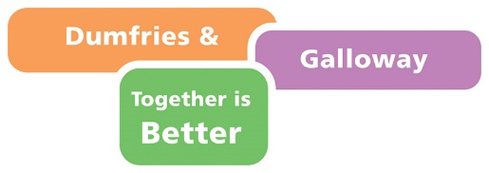

NOLB Work Placement (25+) Application Form

Please contact your Work Coach or Employability Key Worker should you require assistance in completing this application. Alternatively, please email DGemployability@dumgal.gov.uk

All applications should be sent to DGemployability@dumgal.gov.uk.

Placement Details

Placement Applied For

Placement Provider (Employer)

Location of Role

Eligibility

I confirm I have the right to work and live in the UK ☐

I confirm I have been unemployed for 12 months or more ☐

I confirm I am not currently in education, training or employment ☐

I confirm I live in Dumfries & Galloway ☐

Name of Work Coach (if applicable)

Name of Key Worker (if applicable)

Your Details

Full Name

Email Address

Home Address

Post Code

Home Phone Number

Mobile Number

Do you hold a full UK Driving License? Yes ☐ No ☐

Do you hold a current PVG? Yes ☐ No ☐

How did you hear about this vacancy?

Your Interest

Please use the space below to tell us why you are interested in this role. Here you can mention relevant skills, qualities, hobbies, interests and achievements.

Employment History

Start Date | End Date | Employer | Job Title / Main Duties

Training & Qualifications

Please use the space below to tell us about any specific training or qualifications you have completed.

Referees

Please give the names and contact details of at least one person who can provide a reference on your behalf. Referees should not be family members.

Referee 1 Name |  | Email
Contact Number |  | Relationship
Referee 2 Name |  | Email
Contact Number |  | Relationship

Disability & Reasonable Adjustment

If you wish to disclose the information, we will guarantee you an interview if you are disabled and meet the minimum criteria for the role.

Do you consider yourself to be a person with a disability? Yes ☐ No ☐
Do you require any adjustments to be made for interview? Yes ☐ No ☐

Please advise of any adjustments required.

Your Privacy

The information you supply will be processed in accordance with the provisions of the Data Protection Act 1998 (the Act) and will be used solely for the purposes of recruitment and personnel administration. You can read Dumfries & Galloway Councils Privacy Statement to learn about how we handle your personal information.

By submitting this application, you give consent to the information being shared with the relevant partners, such as the Placement Provider (Employer), for the sole purpose of completing the recruitment process.

How to Apply

Please complete and email a copy of your application to DGemployability@dumgal.gov.uk before the advertised Closing Date of the role applied for. You may also attach a copy of your CV in support of your application, should you wish to do so. Please consult your Work Coach or Employability Key Worker should you require advice or support in completing this application.

