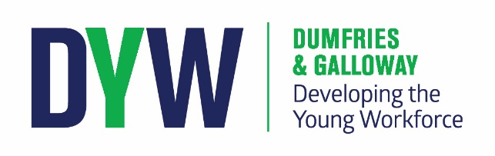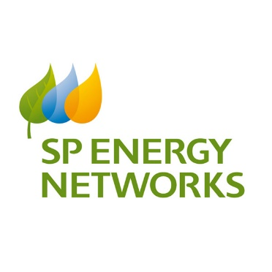
SP Energy Networks [SPEN] is part of the Scottish Power Group of companies. They provide power on behalf of supply companies through a network of cables and power lines that they own and maintain throughout Dumfries and Galloway.
SCHOOLS Scottish Power Energy Apprenticeship Recruitment
20 FEBRUARY at DUMFRIES HIGH SCHOOL, AND 21 FEBRUARY at ANNAN ACADEMY
The presentation is to raise the profile of SPEN within the D&G area and to encourage recruitment within our area. The plan is to encourage genuinely interested students to apply to SPEN for any of the programmes promoting Apprenticeships. The apprenticeship training will be inclusive of training in one of our three craft roles Overhead Lines, Jointing or Fitting, with the possibility of multi-skilling in one of the other crafts. Position applications are available on line from 19 February 2018.
First Hand technical talk and presentations from current apprentices:
2 Modern Apprentices demonstrating Over-head lines work and Jointing.
SCHOOLS & PROGRAMME DATES:
20 FEBRUARY : DUMFRIES HIGH SCHOOL 10am to 11.30am : All Schools welcome. Interested students must register with your DYW teacher.
21 FEBRUARY: ANNAN ACADEMY 10am to 11.30am : All Schools welcome. Interested students must register with your DYW teacher.

For students [ 4th-6th year] interested in a career with SPEN, please register with your DYW teacher.

For specific information on the Application Process and Stages please go to:
https://www.scottishpower.com/pages/how_to_apply.aspx

SPEN WEB SITE : www.spenergynetworks.co.uk

